Day 16 – Introduction to Azure Private Link

What is Private Link:
Azure Private Link is the Azure networking feature, that provides private connectivity to Azure services and customer-owned services over the Microsoft backbone network.
Private Link enables you to access Azure PaaS Services (for example, Azure Storage and SQL Database) and Azure hosted customer-owned/partner services over a private endpoint in your virtual network.
Traffic between your virtual network and the service travels the Microsoft backbone network.
Note: In AWS, the equivalent of Azure Private Link is AWS Private Link.

Resources supported by Azure Private Link:
Azure Storage, Azure SQL Database, Azure Cosmos DB, Azure Key Vault, Azure App Service, Azure Container Registry (ACR), Azure Event Grid, Azure Event Hubs, Azure Service Bus, Azure Database for PostgreSQL, Azure Database for MySQL, Azure Cache for Redis, Azure Machine Learning, Azure Monitor, Azure Backup, Azure Automation, Azure IoT Hub, Azure Batch, Azure AI Search, Azure Kubernetes Service (AKS), and many more.

Choose Private Link if:
- your priority is secure, private, and controlled access to Azure services or your own premises services— without using the public internet.
- You want to access PaaS services like Azure Storage, SQL Database, or Key Vault via private IPs.
- You require no public exposure, no internet routing, and end-to-end private connectivity.

Private Link component or types:
Azure Private Link consists of two primary components:
- Private Endpoint
- Private Link Service
Note: Private Endpoints and Private Link service are components of Azure Private Link, but they serve different roles within the Private Link architecture.
Private Endpoint allows consumers to privately connect to a service.
Private Link Service allows service providers to privately expose their own services (typically behind an Azure Standard Load Balancer).

Let’s understand one by one:
Private Endpoint:
Azure Private Endpoint is a network interface that allows you to privately connect your virtual network to Azure services using a private IP address from your VNet. (Like: Azure Storage Azure Cosmos DB, Azure SQL Database etc.)
This network interface connects you privately and securely to a service that's powered by Azure Private Link.
By enabling a private endpoint, you're bringing the service into your virtual network.
Azure Private Endpoint provide a direct, private connection to Azure resources by assigning a private IP address from your virtual network (VNet) to the service.
When a service is accessed via a private endpoint, the connection stays within the Azure network, preventing exposure to the public internet.
Choose Private Endpoints if:
- Your application requires full isolation from the public internet, such as for sensitive workloads or highly regulated data.
- You want traffic to flow entirely within the private network, ensuring complete confidentiality.
- You need to maintain strict security standards for applications that interact with services like databases, storage accounts, or other critical infrastructure.

Note: In AWS, the equivalent of Azure Private Endpoint is " Interface VPC Endpoint (via Private Link)".

Private Endpoint Architecture:
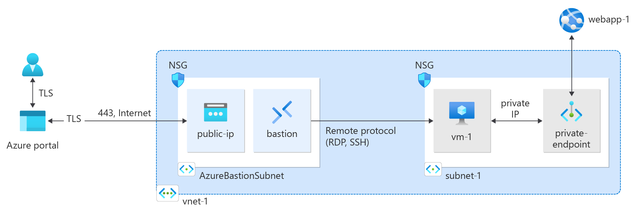

Private Link service:
Azure Private Link service is the reference to your own service that is powered by Azure Private Link. Your service that is running behind Azure Standard Load Balancer can be enabled for Private Link access so that consumers to your service can access it privately from their own VNets.
Your customers can create a private endpoint inside their virtual network and map it to this service.
We can expose our own service (hosted behind a Standard Load Balancer) as a Private Link Service.
Also, Other VNets (even in different Azure subscriptions or regions) can connect to your service via Private Endpoints.

Private Link service Architecture:
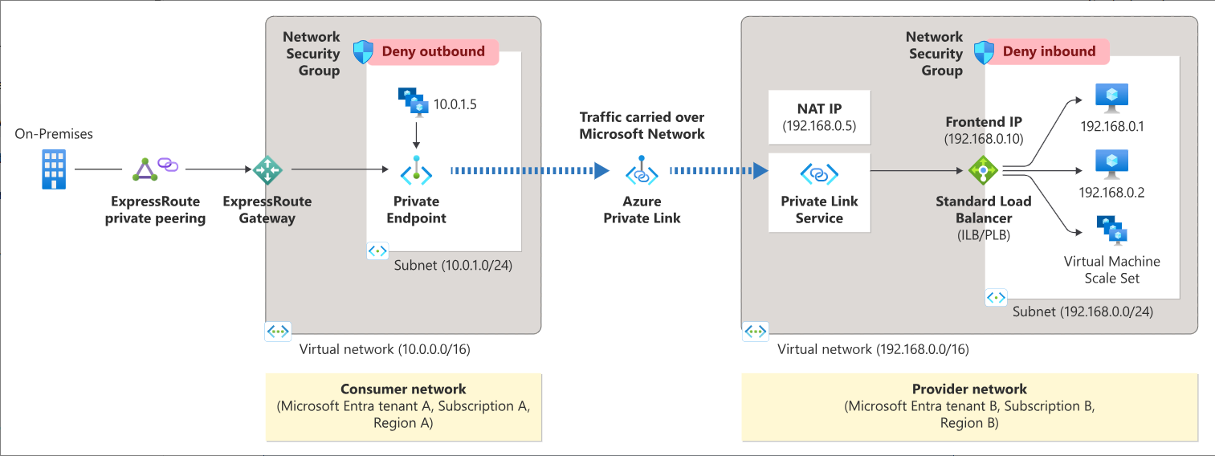

Difference between Azure Private Endpoint and Azure Private Link Service?
Azure Private Endpoint is a network interface that connects you privately and securely to a PaaS service (like Azure Storage, Azure SQL, etc.) or your own service (via Private Link Service) using a private IP address from your VNet. The key benefit is that traffic between your VNet and the service stays on the Microsoft backbone and doesn't traverse the public internet. It simplifies firewall rules and eliminates the need for public IPs.
The Azure Private Link Service takes this a step further, allowing you to extend your Private Endpoints to business partners or customers. This service requires an approval process as an added layer of security to prevent unintended access to your internal resources.

Difference between Azure Service Endpoint and Azure Private Link?

Service Endpoint | Private Link
Firstly, it's important to remember that traffic to a Service Endpoint still leaves your virtual network and accesses the Azure PaaS resource using its public IP address — however, it's routed over the Azure backbone network rather than the public internet. | Private Link is a newer solution than Service Endpoints. with Private Link the PaaS resource sits within your VNET  and gets a private IP on your VNET. When you send traffic to the PaaS resource, it does not leave the virtual network.
Service Endpoints can only be used by traffic originating within your Azure Virtual Network — they do not support access from on-premises networks over VPN or ExpressRoute. | Traffic stays entirely within the Microsoft Azure backbone network and does not traverse the public internet, even though the service has a public IP.
If you want on-premises access to the PaaS service, you must instead allow access via public IP whitelisting or consider using Azure Private Link. | This allows access from both Azure and on-premises environments (via VPN or ExpressRoute) securely and privately, without needing to expose the service to the public internet.
Service Endpoints work by enabling a subnet, or subnets, on your virtual network to support Service Endpoints. | Private Link works by creating a private endpoint (a network interface) inside your VNet that connects you privately and securely to the service.
Connects via Public IP | Connects via Private IP
Very simple | More complex
Free | Not free

Difference between Azure Private Endpoint vs. Azure Service Endpoint:

Azure Private Endpoint | Azure Service Endpoint
Connection Type: Uses a private IP address from your VNet | Uses a public IP address but routed through Azure's backbone network.
Use Case: Ideal for critical security and isolated traffic. | Best for connecting to Azure services with basic security requirements
Supported Services: Limited to resources that support private endpoints. | Supports a broader range of Azure services like Storage, SQL, etc.
Security: Higher security, no exposure to the public internet. | Lower security as it still uses public DNS and IP.
DNS Resolution: Requires DNS configuration to resolve private Ips. | Relies on public DNS for resolution.

